These pages are designed to show you how to use software packages; various software updates may have taken place so some pages will not apply to versions other than those listed here. In some cases data files may be required.

Title or Task: | Excel Calculations
Description: | Using Excel

Files Required
Suitable for Classes: | AIT • Multimedia • Cert II IT • Cert II Bus
Area: | Technology & Enterprise
Teacher: | Mr Peter Faulks

Timeline

Date Due:
Task Brief: | In class lesson
Outcomes: | Begin using Excel

Items highlighted in yellow are tasks for you to complete


Items in Blue italics are help tips

MXL021 Calculations in Excel

Entering Calculations
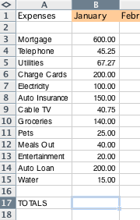

In the cell B17 type =

We can add the expenses one by one by clicking on a cell and putting + into each calculation
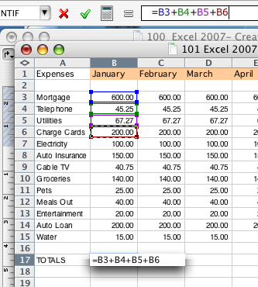

But we can add all the calculations as a sum = SUM (Drag through selection to add)
In this case the range is all the expenses for January (B3:B15)
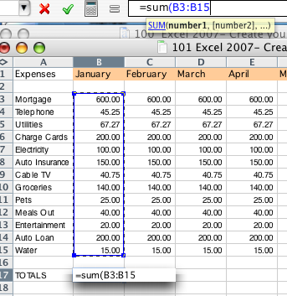

We now have the total expenses for January.

We can AutoFill the sum totals cross each month. Do this now.

Excel automatically recognizes the sum for each month.

Underneath TOTALS in cell A19 type Income and the following…

Salary 4800
Overtime 150
Other Income 45
Sub Total Income +++
Deductions
Tax Sub Total *.20
Other 1 40
Other 1
Sub Total Deductions +++

Total Income Sub Total Income - Sub Total Deductions

Bank Balance = Income - Expenses

Now you may notice that we have moved so far down we cannot see to top of our list we can Freeze either top row or first column or split the worksheet into four, however you can select the split yourself.

Move the split bar to just below the top row.
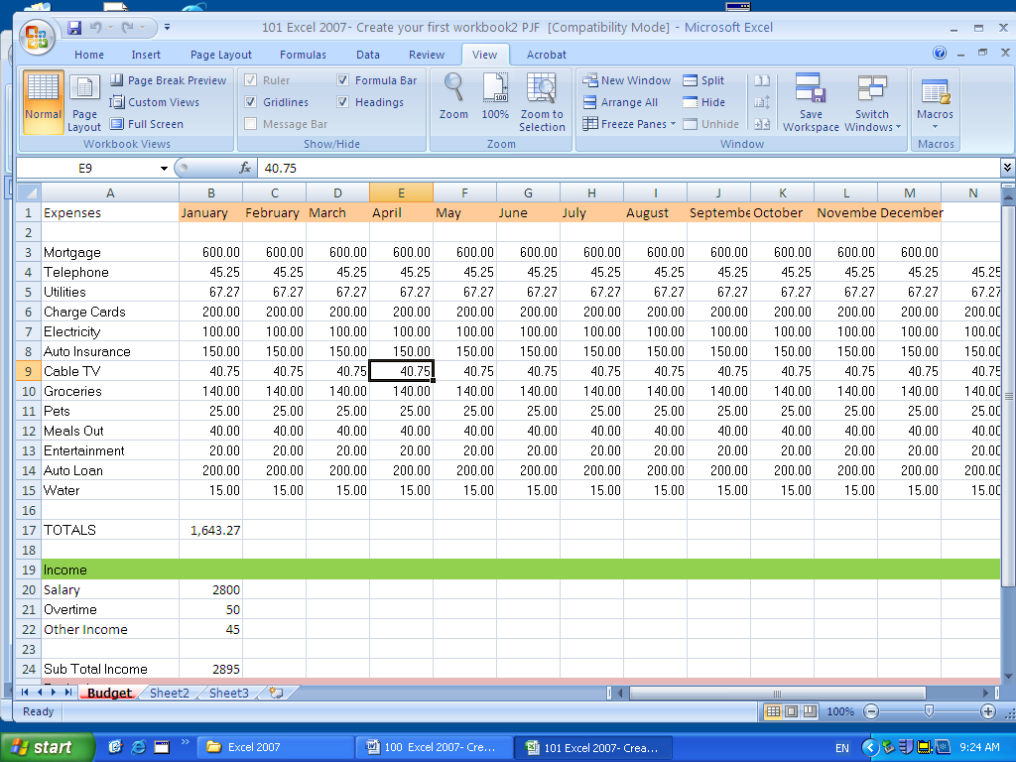
Drag down to just below months.
Split Bar
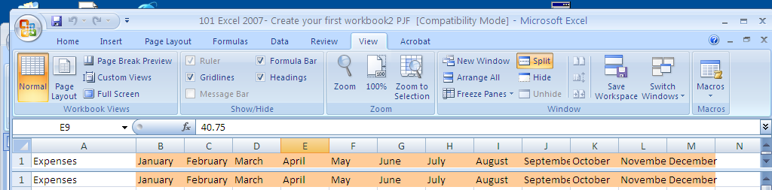

Do the same for the first column
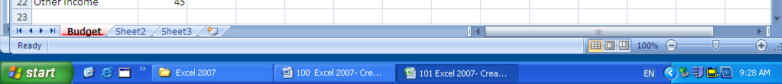
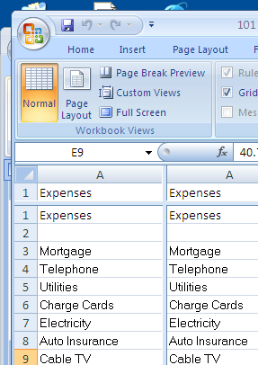
Splits Horizontal (Row) and Vertical (Column)

Open the spreadsheet to compare your work with the sample
100 Excel 2007- Create your first workbook2 PJF

Add formulas that show the average, maximum and minimum for each expense item, add a grand total of expenses for each expense at the end of the year.

Find calculation results without using a formula

You can calculate sums, averages, and other values without creating a formula.

1. If the status bar isn't visible, click View, and then click Status Bar.

2. Select the cells whose values you want to calculate.

The calculation result displays in the center of the status bar.

3. To change the calculation type, click the status bar and then click a calculation type on the menu.

